**Uttarakhand**

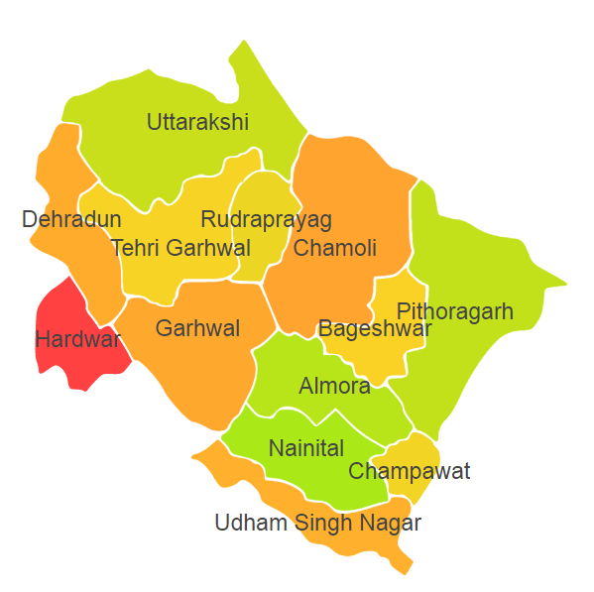

Uttarakhand comprises of two Agro Ecological Regions (AER) 9 & 14.

**Agro-Eco Region 9:** AER 9 in Uttarakhand comprises of Haridwar and Udham Singh Nagar districts of Eastern Ghats under Agro Ecological Sub Regions (AESR) 9.1 & 9.2.

**Agro-Eco Region 14:**AER 14 in Uttarakhand comprises of Almora, Bageshwar, Chamoli, Champawat, Dehradun, Nanital, Pithoragarh, Purbi Garhwal, Rudraprayag, Tehri Garwal and Uttarkashi districts of Western Himalayas under Agro Ecological Sub Regions (AESR) 14.2,14.4 & 14.5.